Session-07

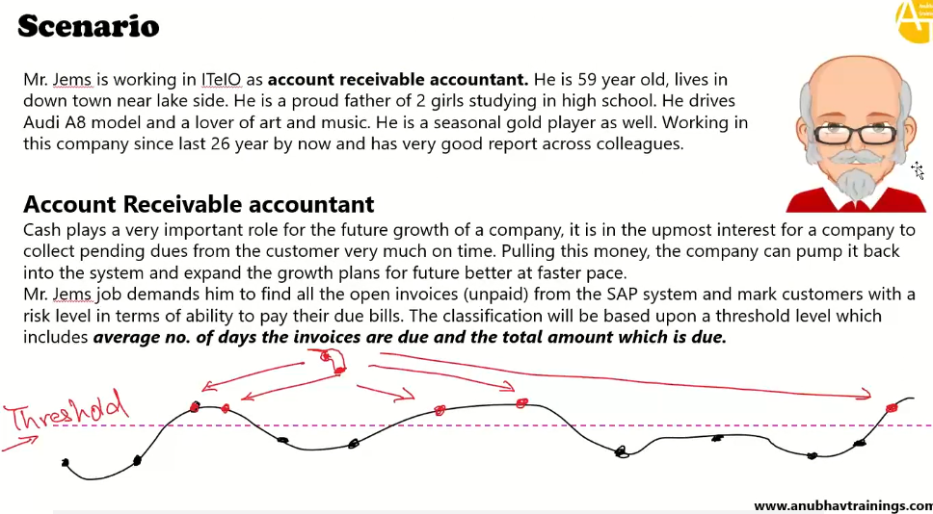

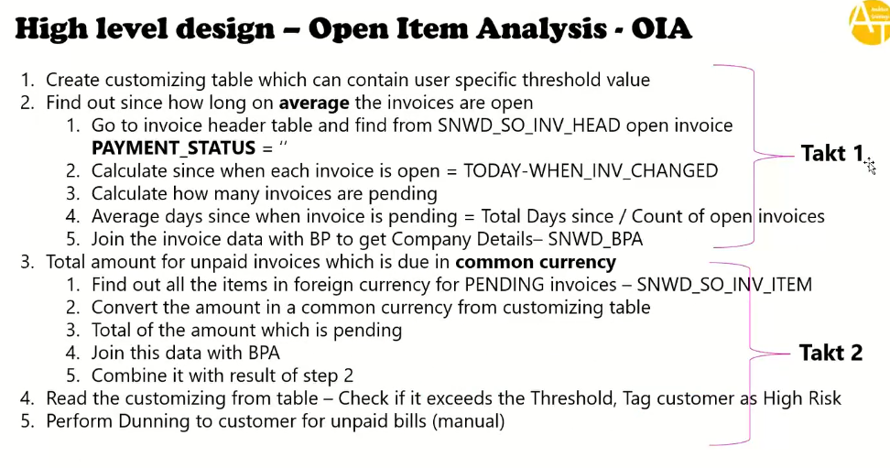

Check the used tables and their relation ship below:

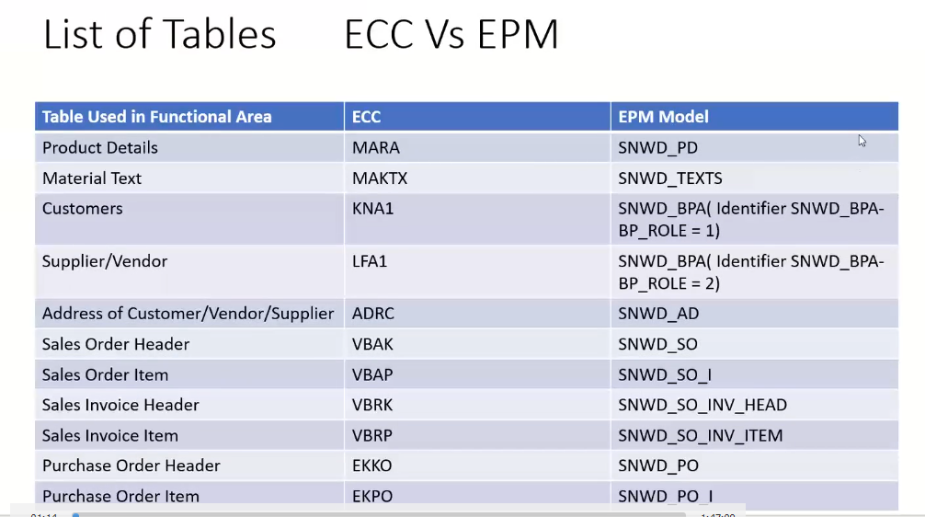

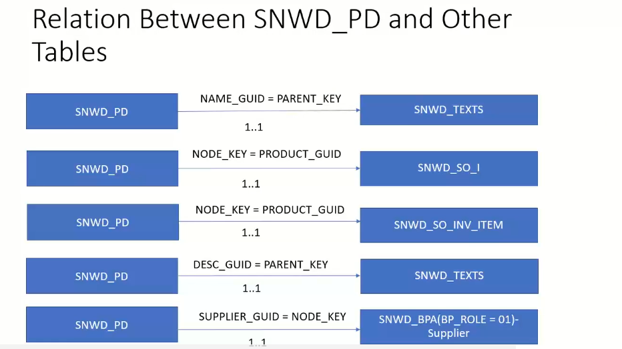

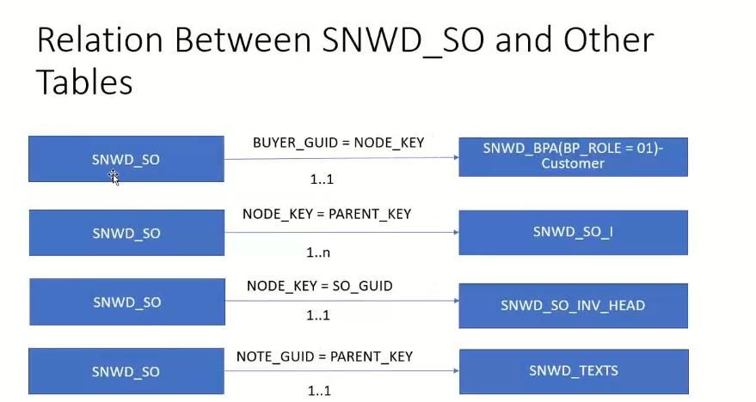

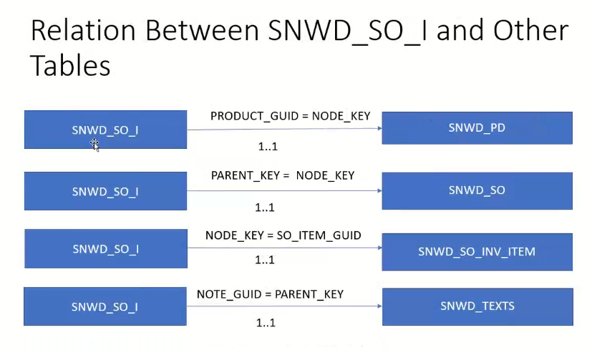

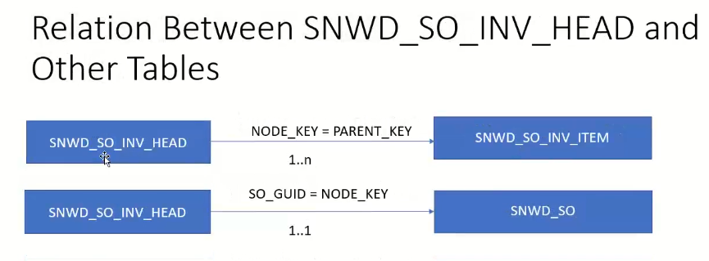

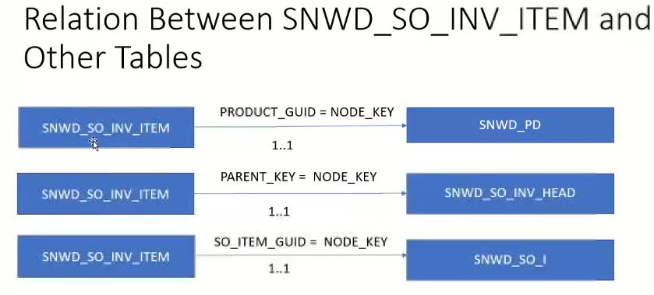

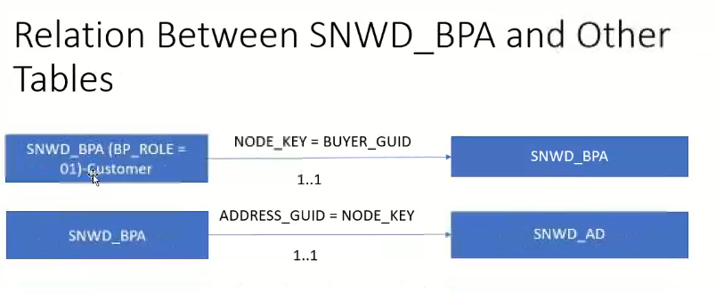

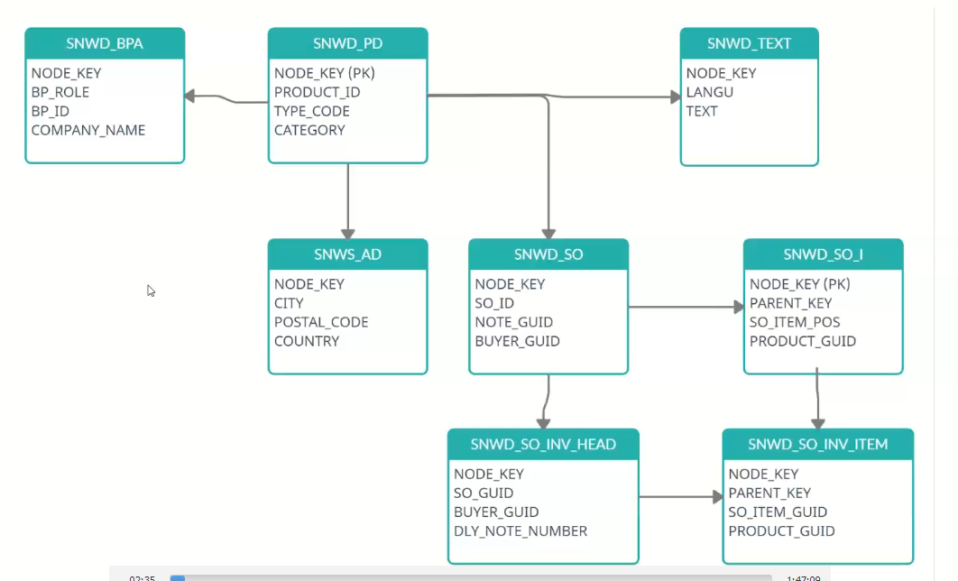

1. Create the customizing Table

Name : ZDP_CUST

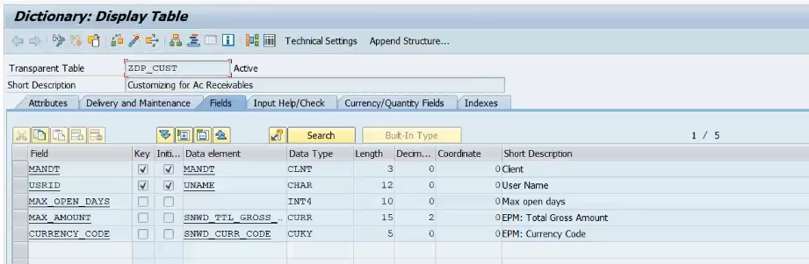

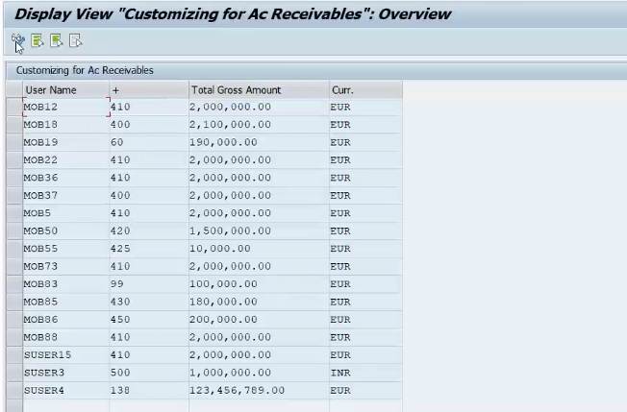

Total gross amount/Number of days exceed 🡪 those customers are high risk customers.

Step-2

Create the Program

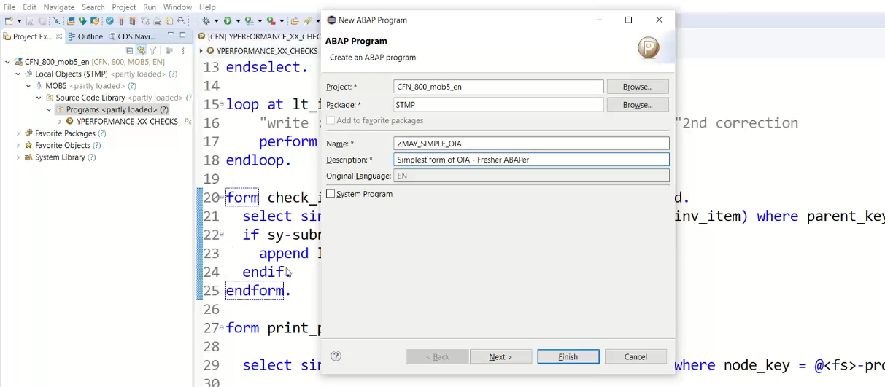

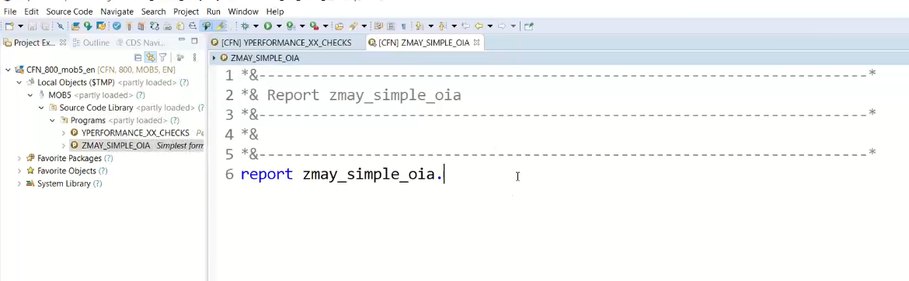

11:00

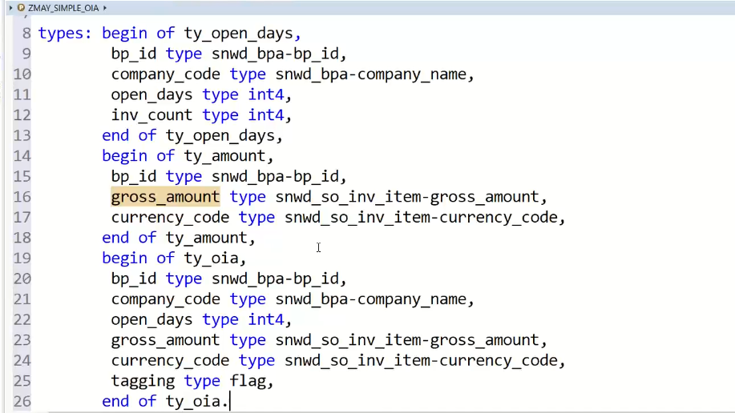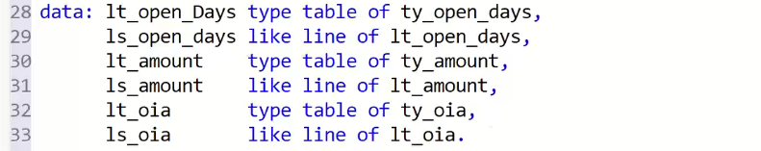



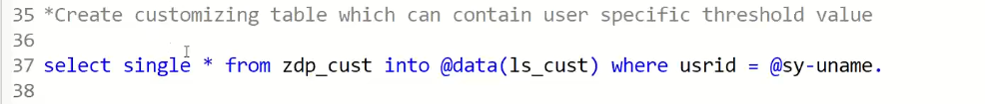

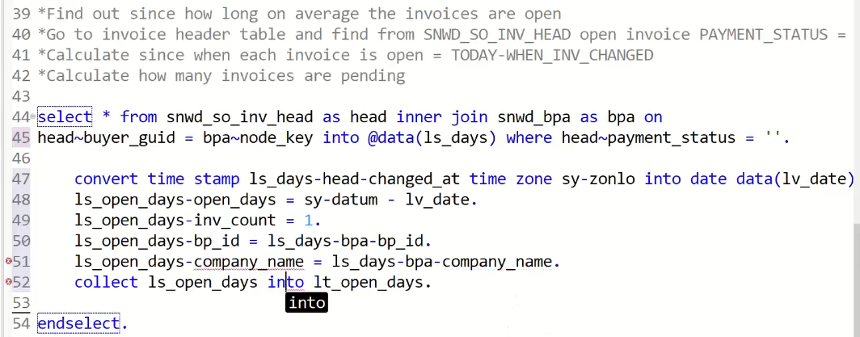

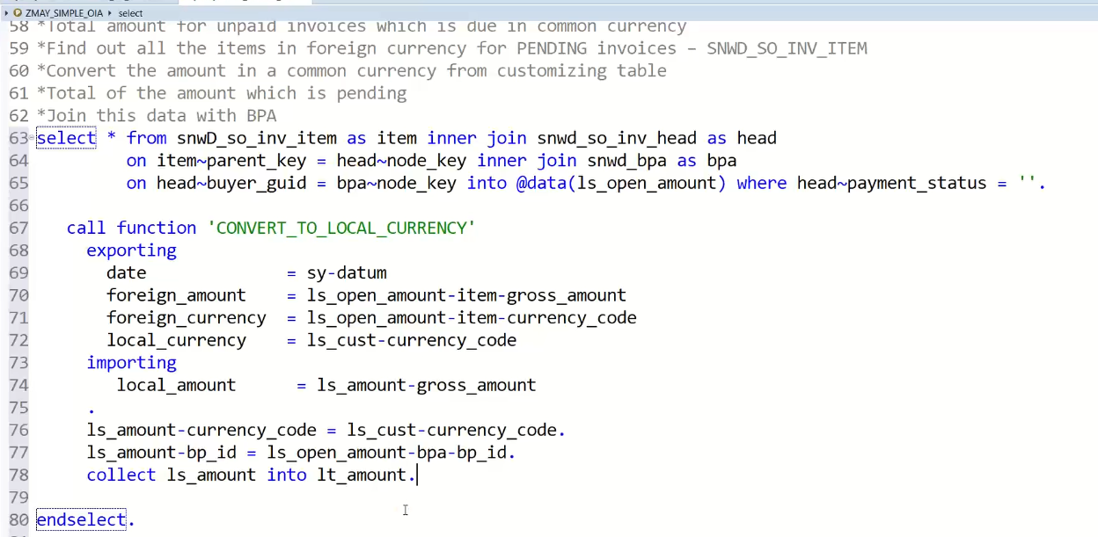

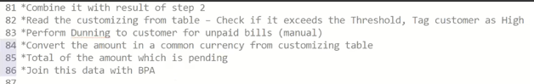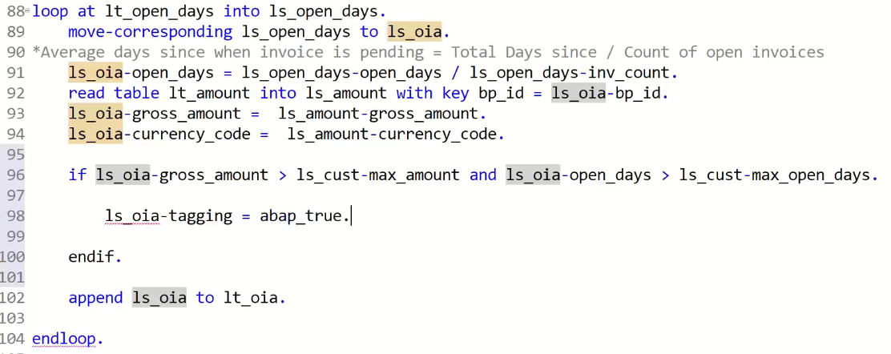

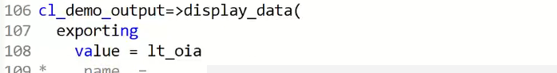

Output:

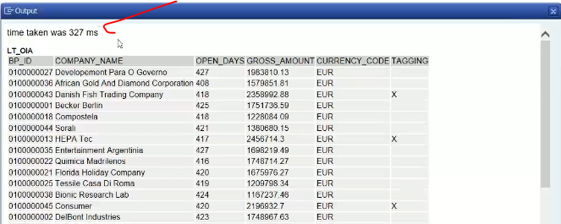

Now our judgement is how much of time is taking…

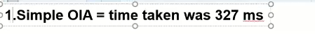

It has taken to 327 ms

Now to improve the performance.

Create program:

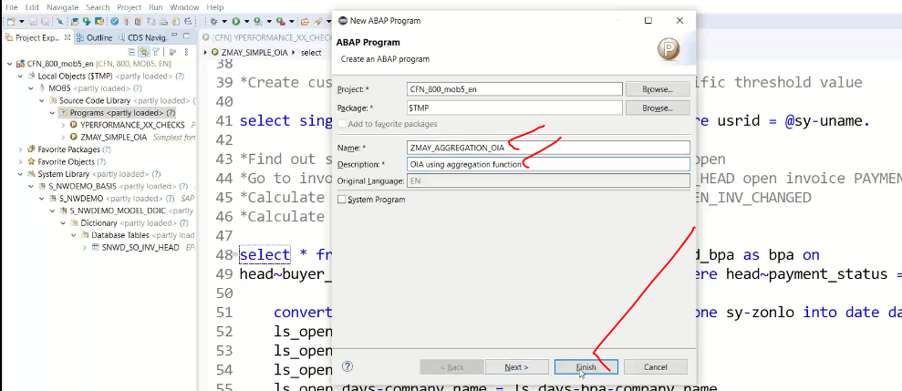

Copy the code previous program code to here.

Note: while using the aggregate functions we need the group by clause.

* Avoid select *

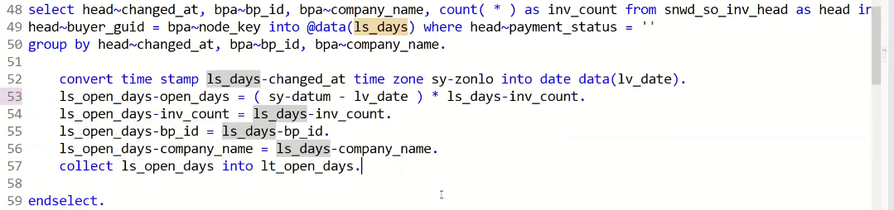

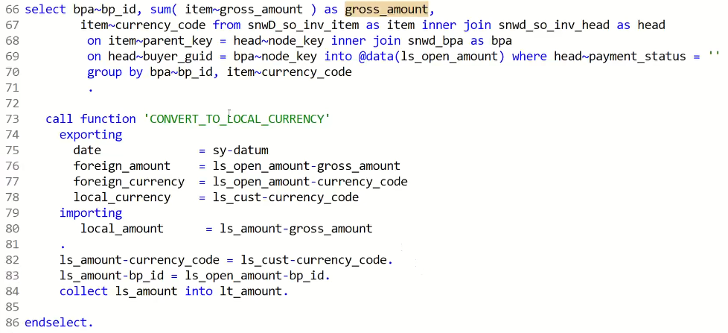

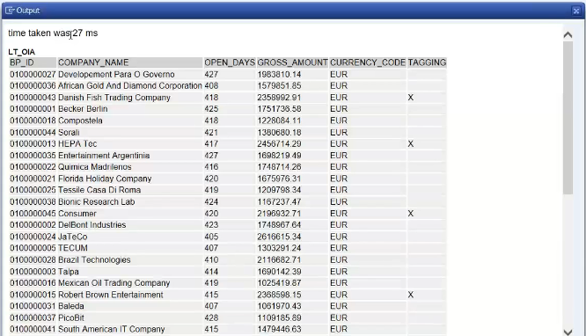

Time has taken is 27 ms 🡪 if it is assume this also huge time has taken.. so what to do

This has done in ABAP layer.. but we need to get better performance in this case we have to use the SAP HANA information modeling. Through information model you will do better performances.

**What is information Model?**

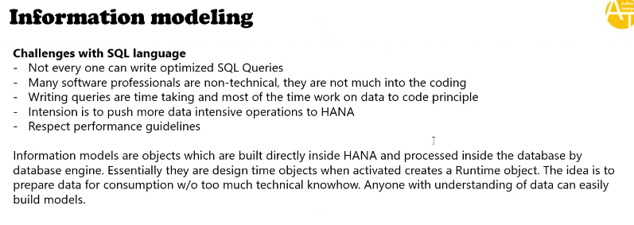

**In hana we have 3 types of information models**



Why they are three/ why not they are one?

* This has divided based on data processing , this three information models are processing differently.
* These types has introduced 2011 after that SAP has improved lot then SAP has deprecated the Attribute view and Analytical view.
* At last we had the one view only i.e Calculation view, this is do the work all the deprecated views such as Attribute view and Analytical View.
* Calculation view has capable do the work of attribute and analytical view.
* analytical and attribute views are deprecated in 2016 🡪 deprecated means not deleted, you can still use the feature which means today also I can create the attribute/analytical views.
  + While using/creating the analytical/attribute view if anything bug found SAP does not support.
  + New tools which are coming such as BAS .. etc no more support for these two views.

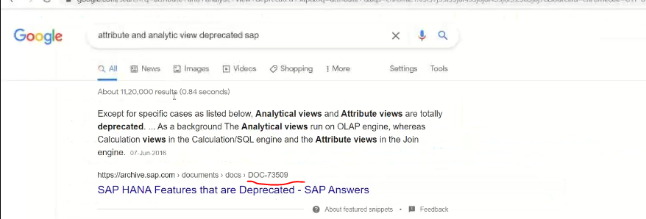

JOIN engine do the joins much faster.

OLAP engine :Good in aggregations

Differences:

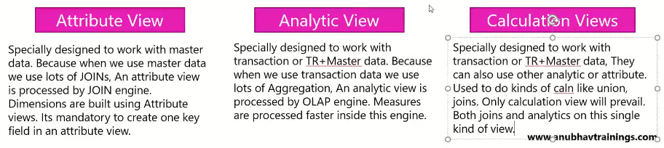

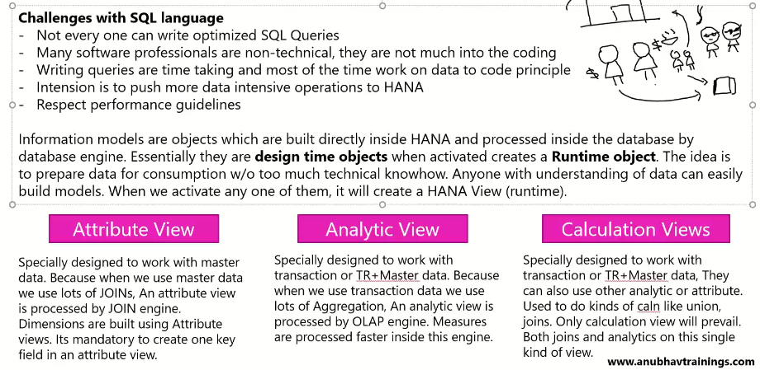

**CREATE THE ATTRIBUTE VIEW:**

**Crete the attribute view for Product and Product Text**

1. Need to login to the HANA Box,
2. Open the HANA Studio
3. Change The prospective to HANA Modeling.
4. Login to that
5. Go to Content folder and select/Create the appropriate the Package.

Note: you will not create the inside the content. You will create the inside the package.

1. Create the package

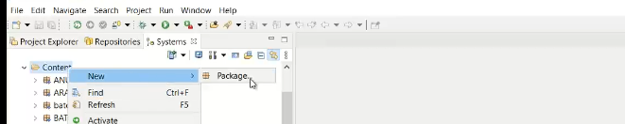

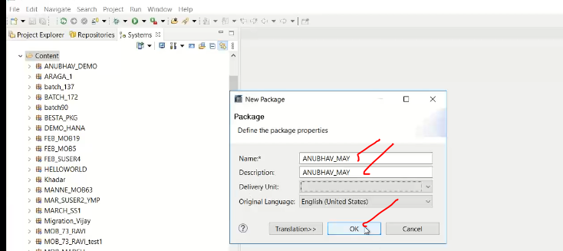

Now ANUBHAV_MAY package has created under the content.

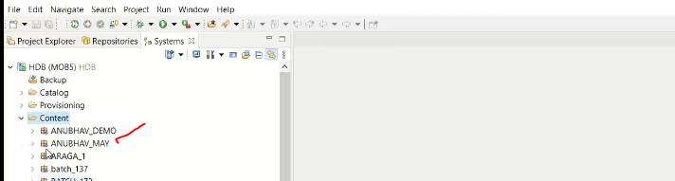

Note: In this package we have to create the design time objects, when you activate the design time object it will create the runtime object inside the catalog schema.

Note: schema is the home of runtime objects.

1. Create the attribute view.

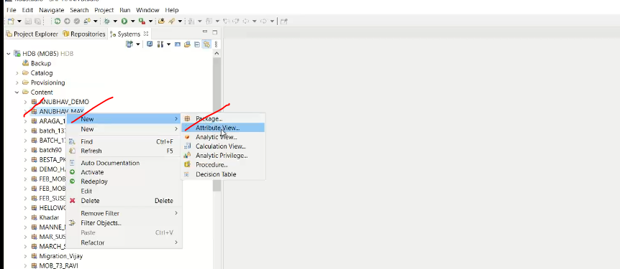

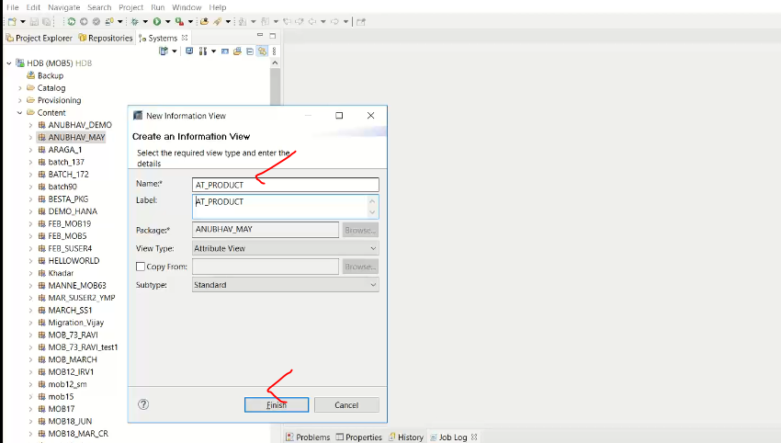

Note:

* + package is the name space for your object.
  + package is different you can create the same object.
  + Package is the same you can’t create the same object one more time.

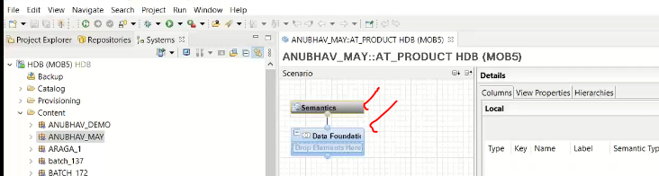

Now add the tables, 1. Drag and drop 2. Click on + button GUI

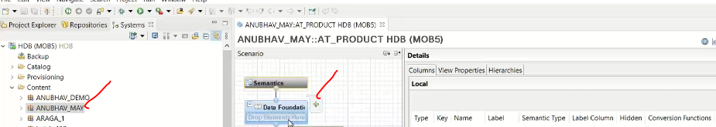

Now click on + button to add the tables

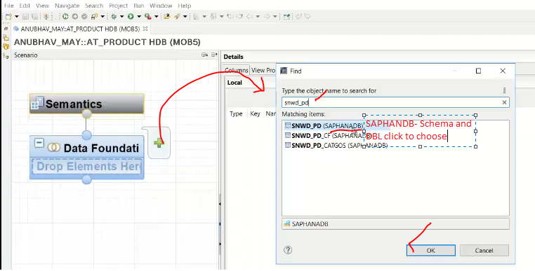

Now it has added to the data foundation:

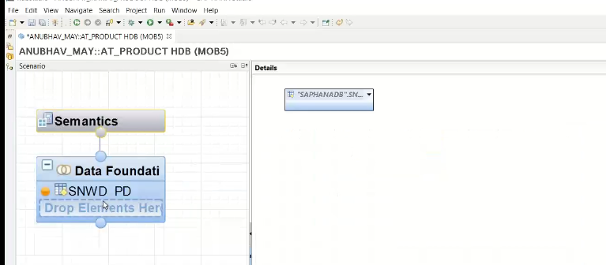

If you click on data foundation.

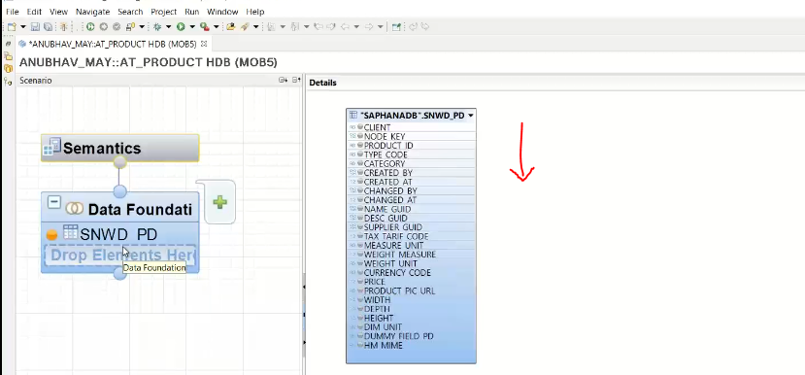

Now add one more table to data foundation and click on foundation and click on + button

And snwd_Texts

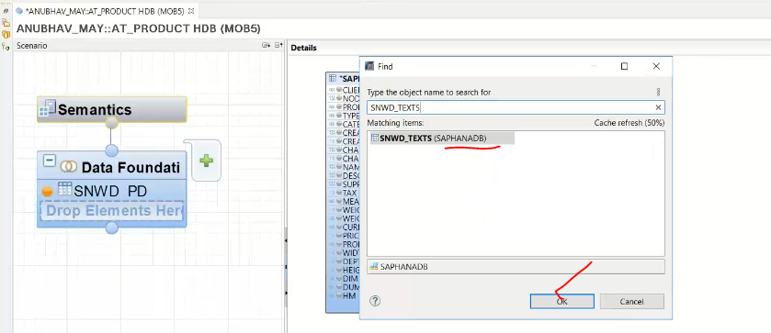

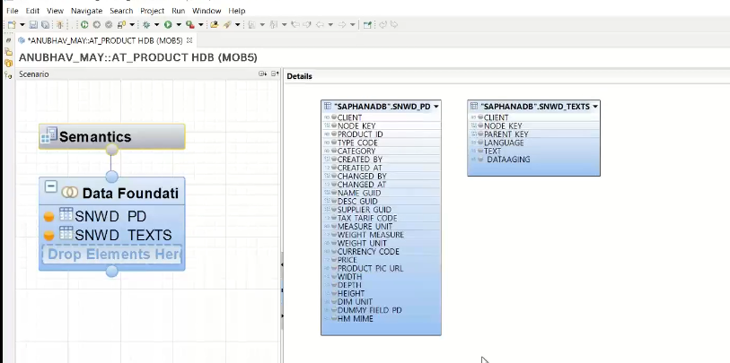

Lets join the both tables.

SNWD_PRD-Client to SNWD_TEXTS -client and SNWD_PRD-desc_guid to SNWD_TEXTS-paren_key

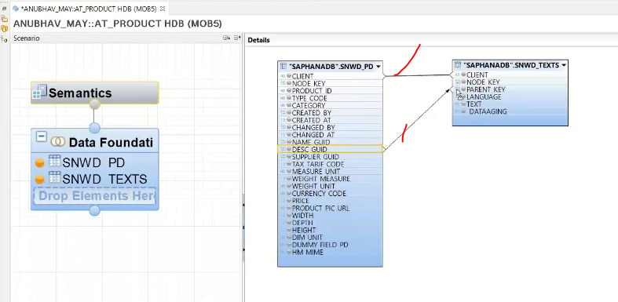

Text table in abap: contains the key field + language field additional

TEXT Join:

* + Join between a table and text table called as text join.
  + Need to maintain as join type is text join
  + Select the language column as “Language”. Is mandatory for text join
  + Which means when I login with English language, select data from view and show me in logon language🡪 this is automatically handle(sy-langu)

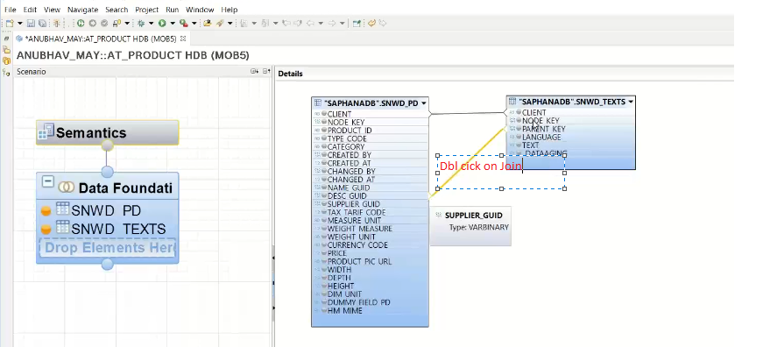

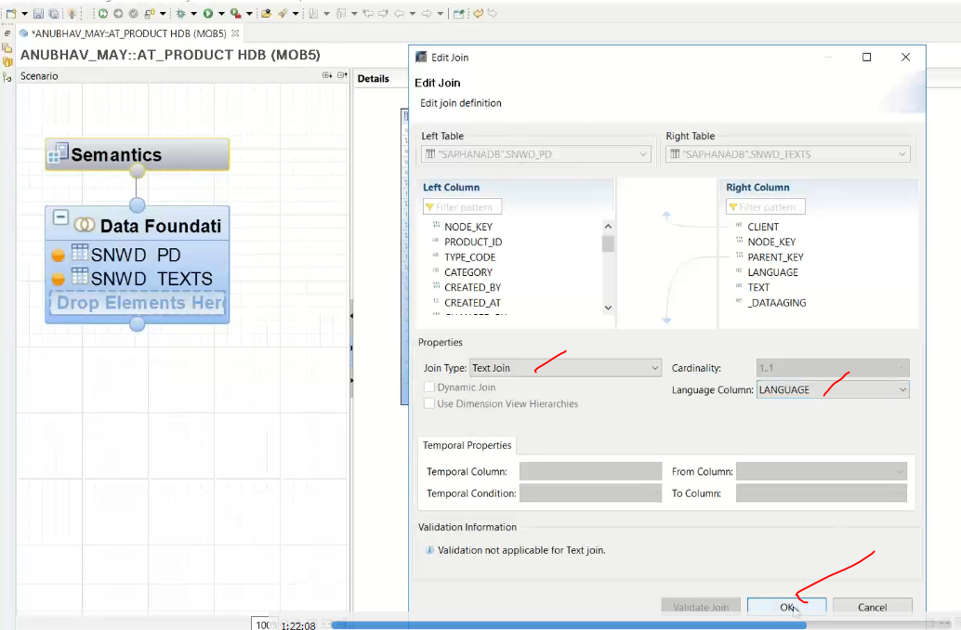

Now text join has done.

Now add the output fields to the attribute view.

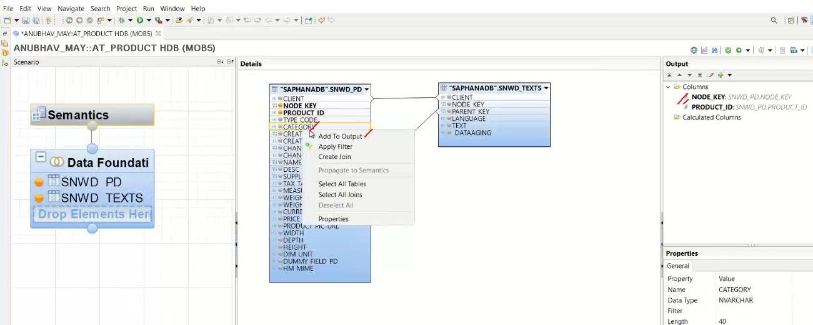

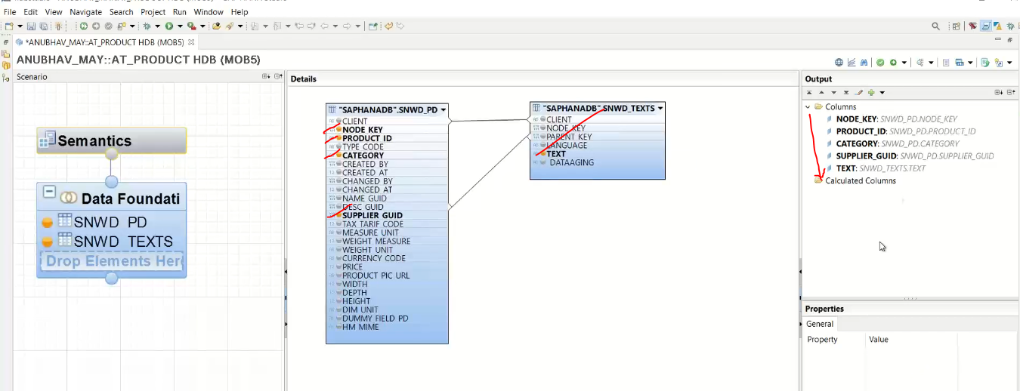

Now activate it.

What happed when you activate the design time object🡪 runtime object will create.

What is the name of the runtime object name.?

* + Click on sematic objects 🡪 go to the view properties

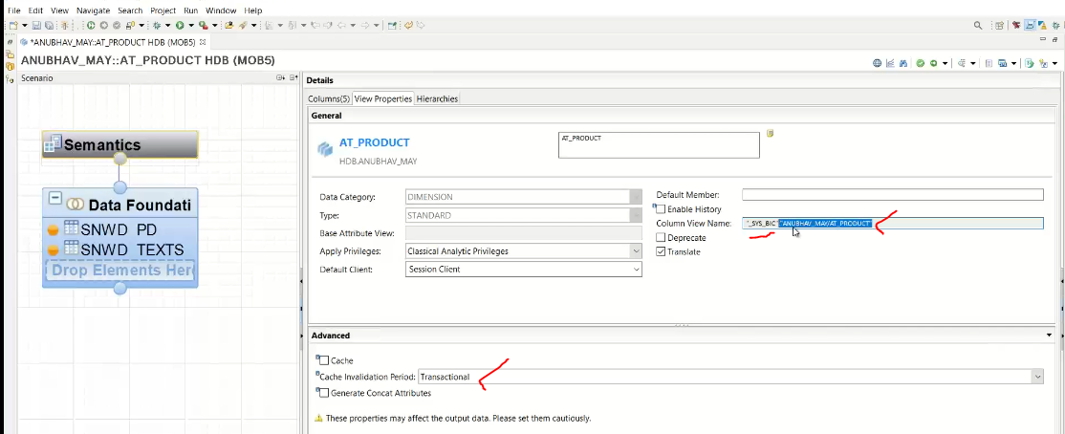

* + It is stored in “SYS_BIC” schema

“_SYS_BIC”.”ANUBHAV_MAY/AT_PRODUCT” ( this is the runtime object) and runtime objects stored under the “_SYS_BIC” schema and “ANUBHAV_MAY” is the package where the design time object has created.

“_SYS_BIC”.”<PKGE Name>/<Object_Name>”

Package serves name space of your object.

Before activating the view we will check the view 🡪 you can go on right side and see this window, where you can see problem during activation of the view.

Check the view first:

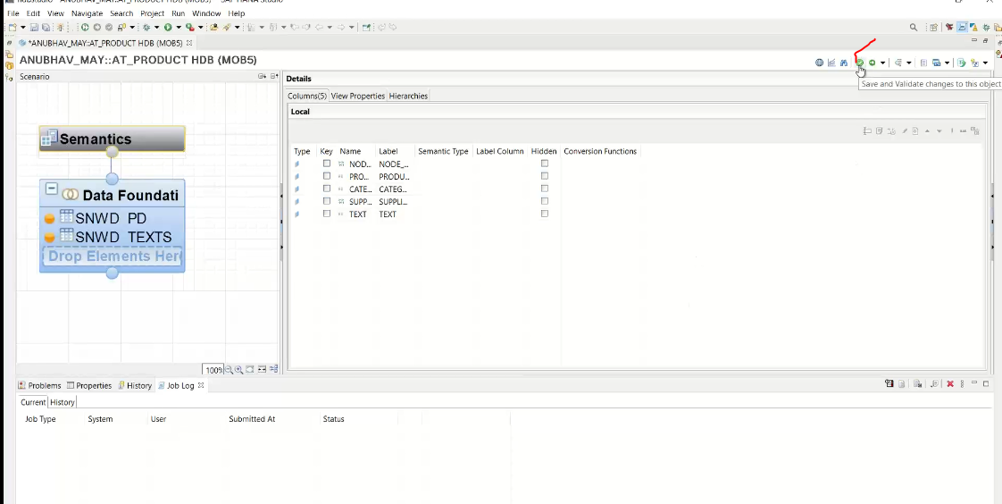

Get error: because attribute view has at least one key.

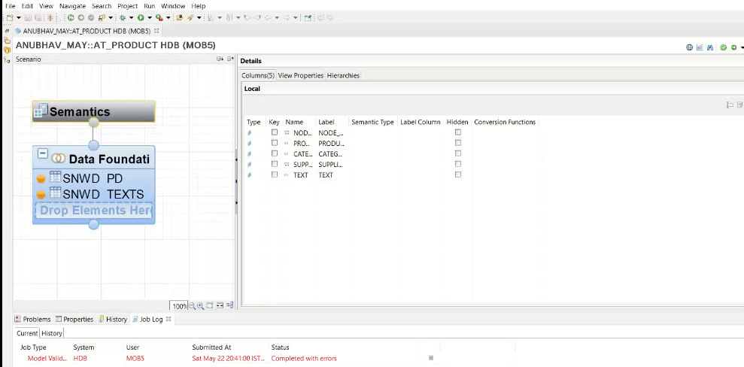 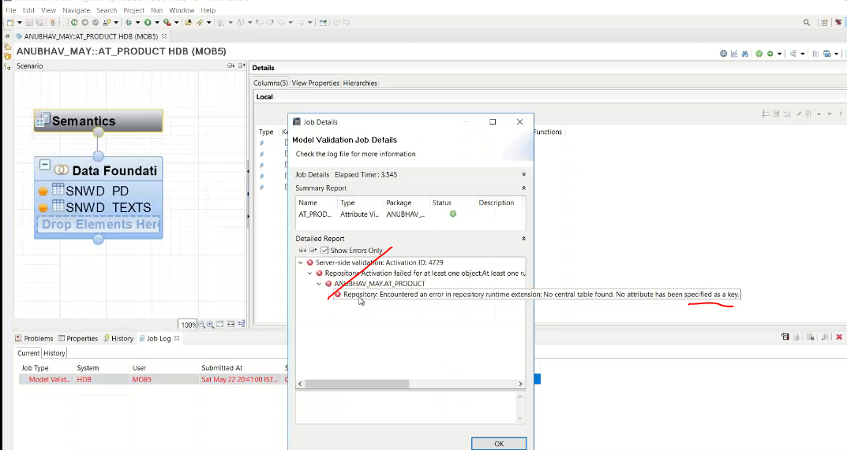

Now define the key in output.

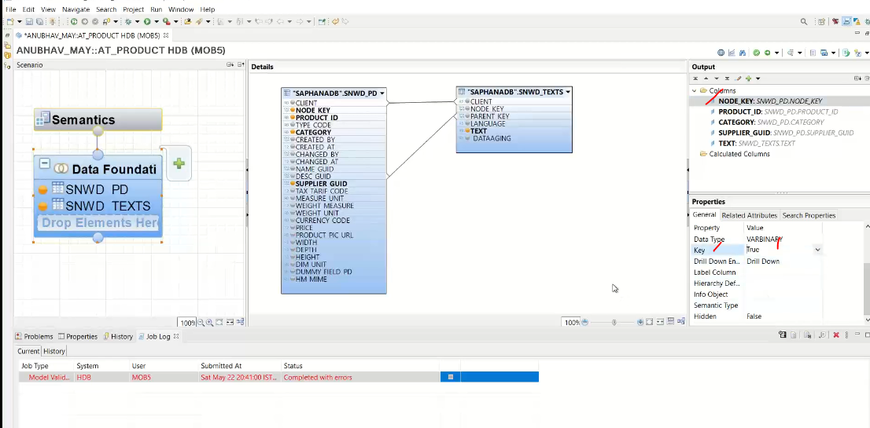

Or

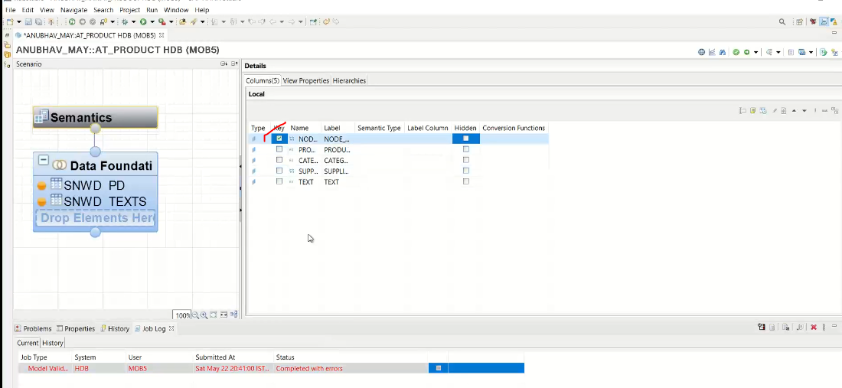

Now once again check.

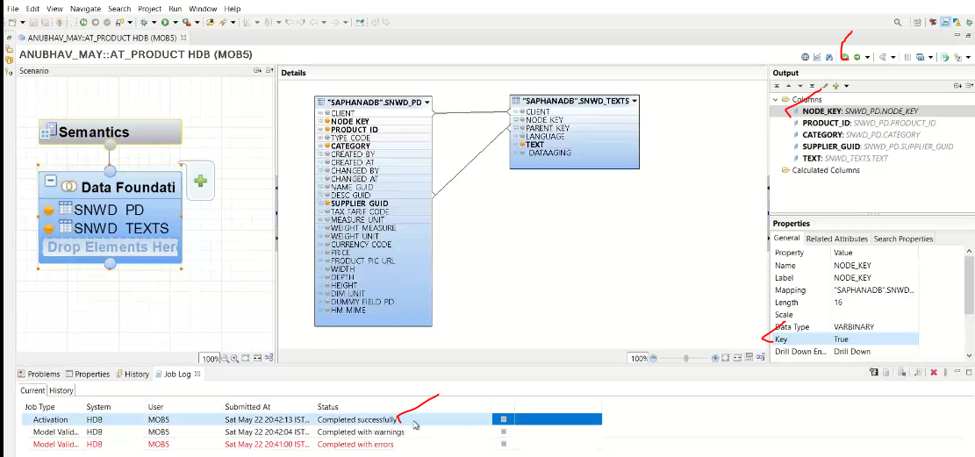

Now see the data preview.

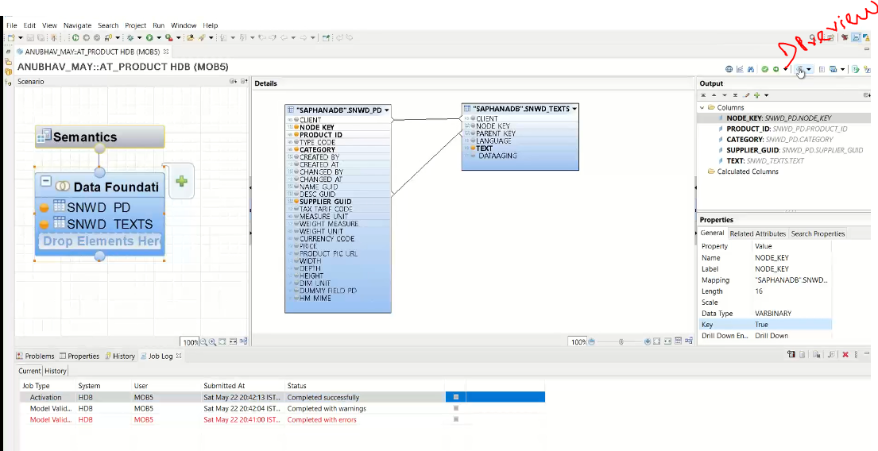 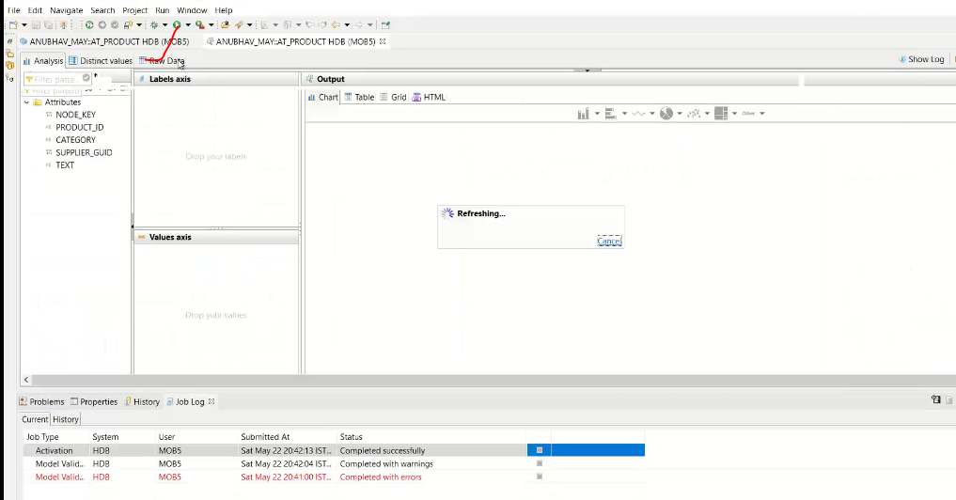

Click on RAW Data

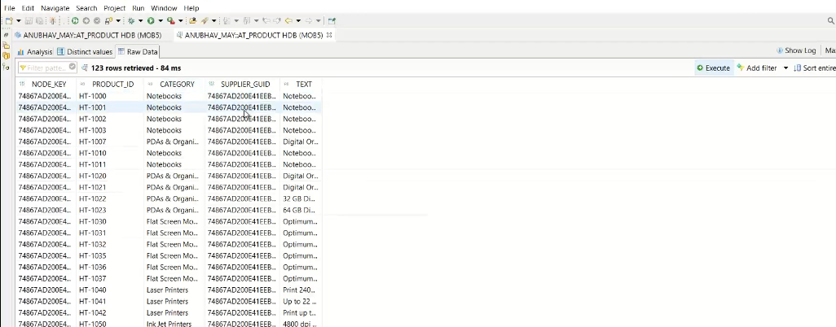

Runtime object has stored under the schema: “_SYS_BIC”.

When you are executing this, it is hitting the runtime object and get the output.

If you want to see the what code has generated while activating.

Dbl click on successful activating

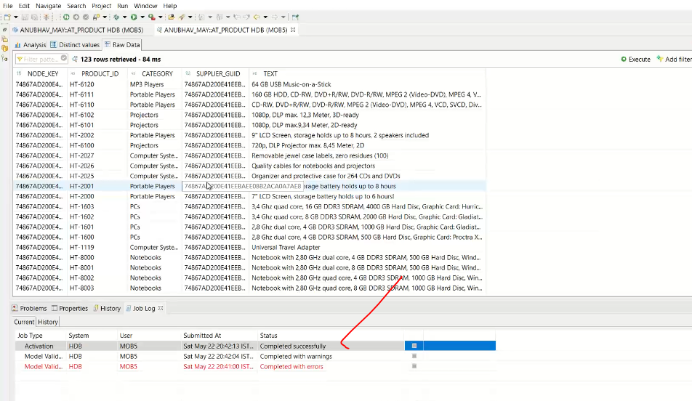

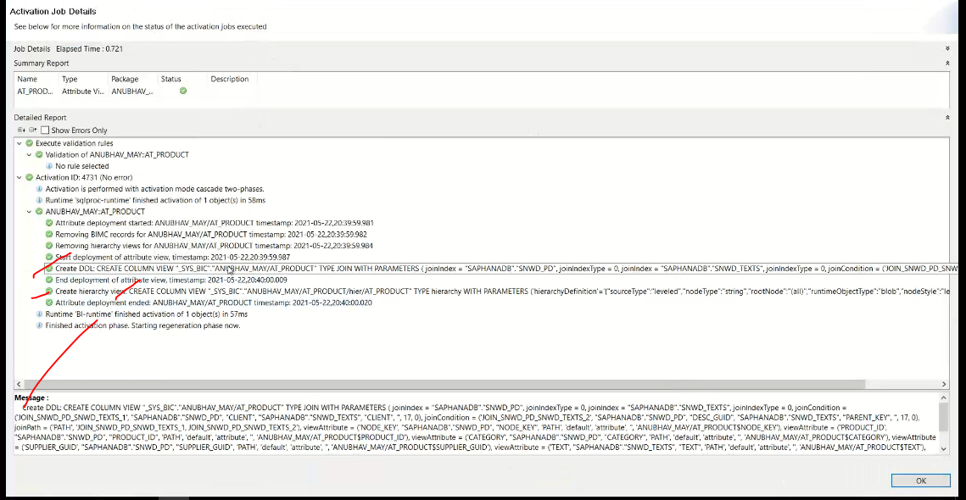

What type of JOINS support in SAP HANA for attribute view?

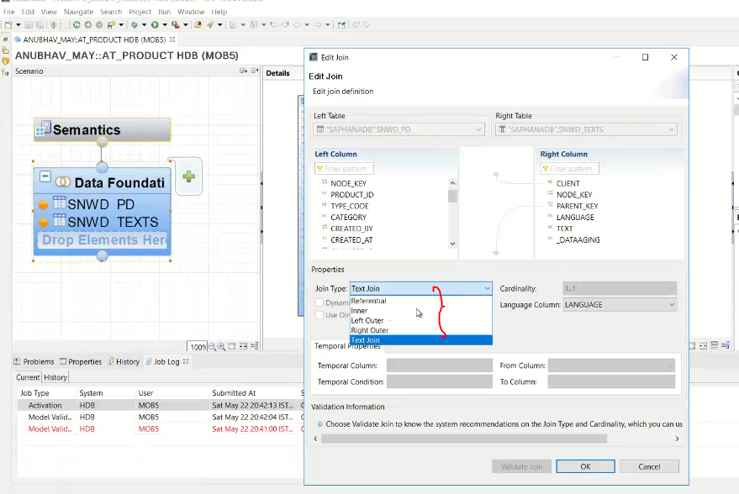

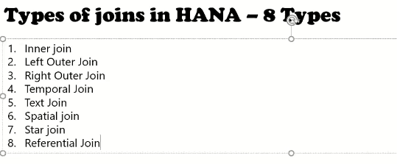

1:31:00

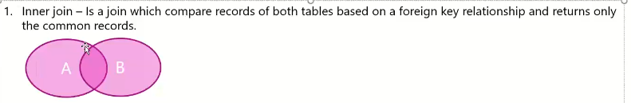

You will get the inter section data only.

Left oute join:

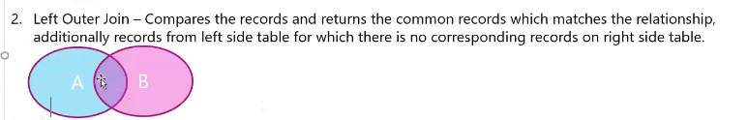

Intersection data + left side of data

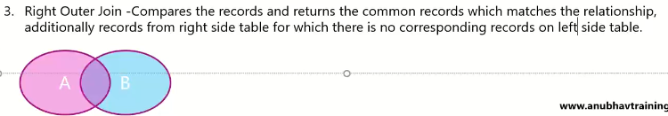

Intersection data + remaining data of B table.

Temporal Join:

* Year/month/date/weekly…
* Called as M* tables stored in “_SYS_BI” schema.



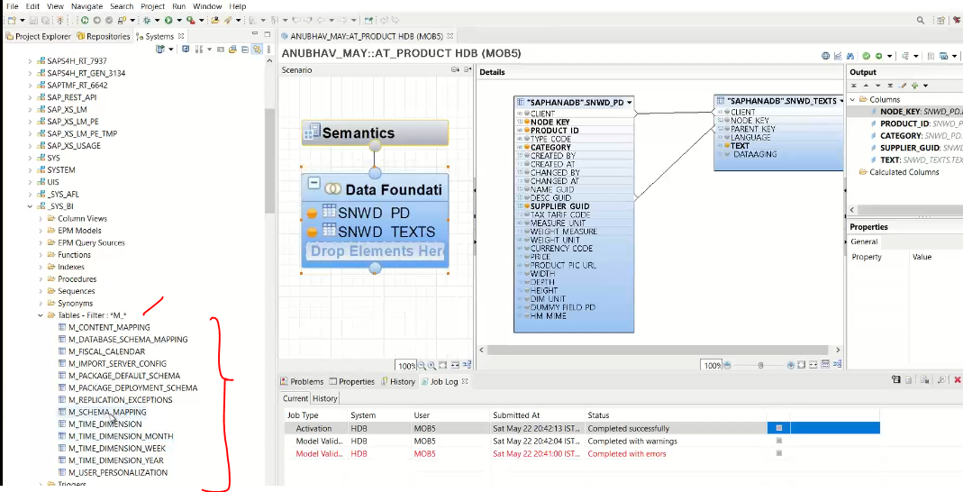

Suppose you want to join with the time based in this case we have joined with the temporal join.

Text Join:



Spatial Join:

* Latitude and longitude data.



Star Join:



ABAP DDIC views are created in SE11 and HANA view created in HANA DATA basae directly.

Convert to Timestamp to Date:



Note : if you look at this invoice header table 🡪 go to table name : SNWD_SO_INV_HEAD 🡪CTRL + CLICK : it will open the table

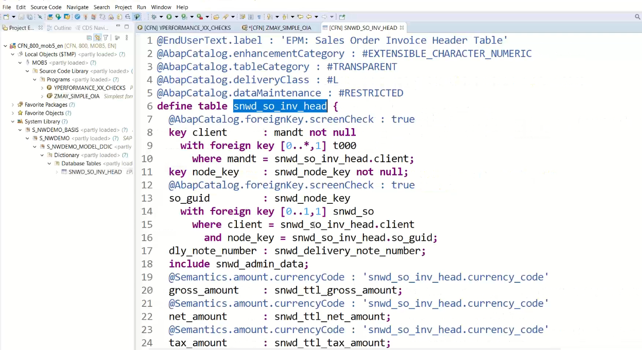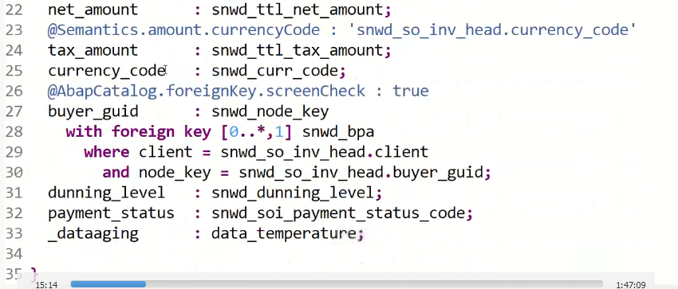

F8 🡪 No data appears

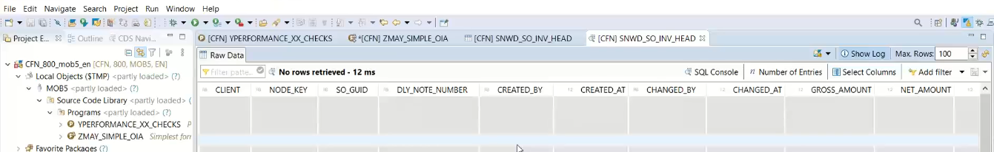

Miscellaneous Topics

For data we need to generate for this SEPM_DG- TCODE

DG- Data Generator

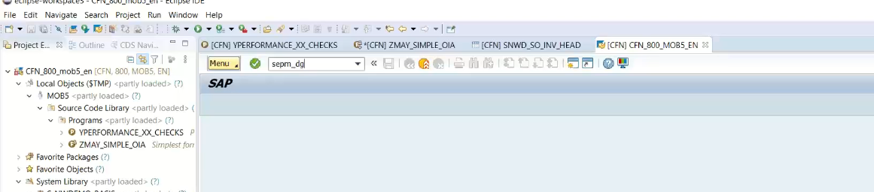

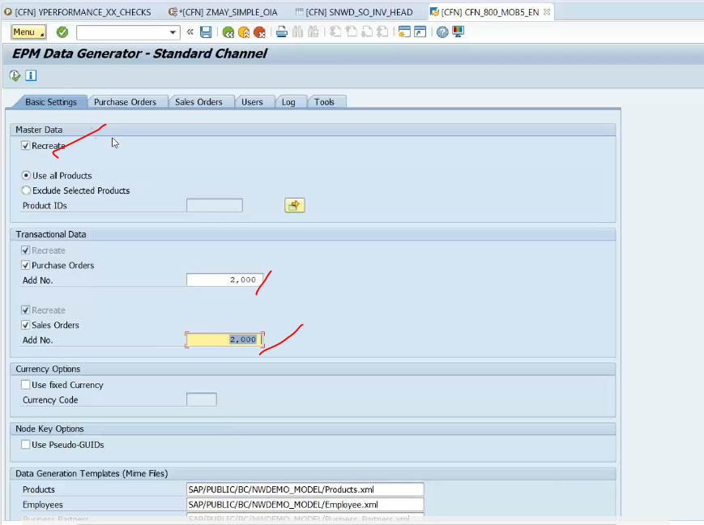

This is only for SO/PO only